1. Run the initial project and do a screen print from the browser.

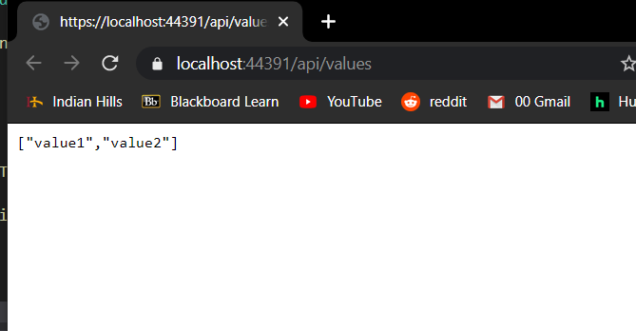

1. Copy and paste the block of code that generates the above response.

["value1","value2"]

1. What is the format of the response from above?

JSON

1. True or False: Model classes must reside in the Models folder in order for the application to function properly.

No but if you don’t it would work with the code in the tutorial and won’t follow MVC

1. What is the purpose of the Id property in Entity Framework?

To work with the database the model needs unique key for the relational database

1. What class does the TodoContext class inherit from?

The database context is the main class that coordinates Entity Framework functionality for a data model.

1. What data type is used to store the to do items?

The ‘name’ is a string the ‘IsComplete’ is a bool

1. What element connects the TodoContext with the corresponding controller?

public DbSet<TodoItem> TodoItems { get; set; }

1. What file was updated to include the dependency injection for the TodoContext?

Startup.cs